Venue Address | [EVENT NAME]  [COMPANY NAME & STAND NUMBER]  [CONTACT NAME]  ExCeL London  Newham  London  E16 1XL
Essential information for delivery traffic and parking at ExCeL London | Improving efficiency for exhibitors and contractors delivering during build-up and breakdown is an essential factor for a successful show.  ExCeL is adopting the Voyage Control pre-show vehicle booking system for deliveries to the show floor to ensure clarity in terms of access and to reduce waiting times.  For a seamless process, it is essential that all vehicles needing access the venue’s loading bays are pre-booked on the ExCeL London Vehicle Booking System.  To book your vehicle please go to excellondon.voyagecontrol.com  Any exhibitor or contractor vehicles that are not booked system will be denied access to the loading bay by the on-site traffic team.  There are instructions on how to make a booking on the next page.
Booking your vehicle  Space-only stands | All exhibitors, contractors and show suppliers must book every time they need to access the loading bays, whether during build-up, break-down or in exceptional circumstances during show open. This does not apply to couriers (please see the Delivering to your Stand section).  Exhibitors will be notified by the organiser that the ExCeL Vehicle Booking System is live 21 days prior to the event’s first tenancy date. No vehicle will be permitted access to the loading bay without a booking confirmation.  PLEASE NOTE  Please arrive no earlier than 15 minutes prior to the confirmed booking time. Early arrivals will cause unnecessary delays and congestion.  We recommend using Google Chrome as the browser to use the system requires an up-to-date internet browser. The system will work on mobile devices and smart phones and has its own dedicated app available through the App Store or Google Play, please search – Voyage Control.  To schedule the loading bay slot for the vehicle, please follow these instructions:  - Sign-up to the ExCeL London booking system by going to this url excellondon.voyagecontrol.com  - Select [show name] and your user type  - The stand location can be identified from the floor plan that is shown in the system. Please make a note of the zone colour as you will need this for later on in the process.  - Select the appropriate event phase (Build Open or Break) and the date when the vehicle will be on site.  - Select the access point (zone colour) and the type of vehicle that is making the delivery.  - Once all details have been entered, press the “Get time” button at the bottom of the page to see the available time slots. Time slots are allocated on a first come first served basis. Time slots and unloading/loading times will vary based on availability, user type and vehicle size  - Once the timeslot is selected, please provide the following details:  - Exhibitor company details  - Delivering company details (if different)  - Stand details  - Driver name  - Origin postcode of vehicle  - Vehicle registration number  Please note if the driver details or vehicle registration number are not known at the time of booking, the time slot can still be reserved, and the details provided at a later date. Please note that all details must be completed prior to arriving at the venue.  - The time slot will be confirmed by email along with the vehicle pass. Please ensure your driver has this before arriving at the venue. This can either be printed or presented electronically.  - Once registered on the system, any time you need to book another slot your details will already be stored associated with your username and password.  - If you need any support using the system or have any questions about its operation, please use the “support” button in the vehicle booking system itself or email the organiser.  Details can be amended, or a booking made at any time before arriving at the venue. This means traffic delays can be taken into consideration as the system will remain live until the end of that day. If driver did not make the booking, please make sure they let the administrator know of any delay so the slot time can be amended.  Contractors building space-only stands are advised that their breakdown booking time is based on when the stand is broken down and ready to load. Do not book the slot for any time before the stand is dismantled, as the driver will not be able to stay on the loading bay beyond the allotted time.
Getting here | Make sure the delivery vehicle you are using is booked on the ExCeL London Vehicle Booking System before arriving onsite. Please arrive no earlier than 15 minutes prior to the confirmed booking time.  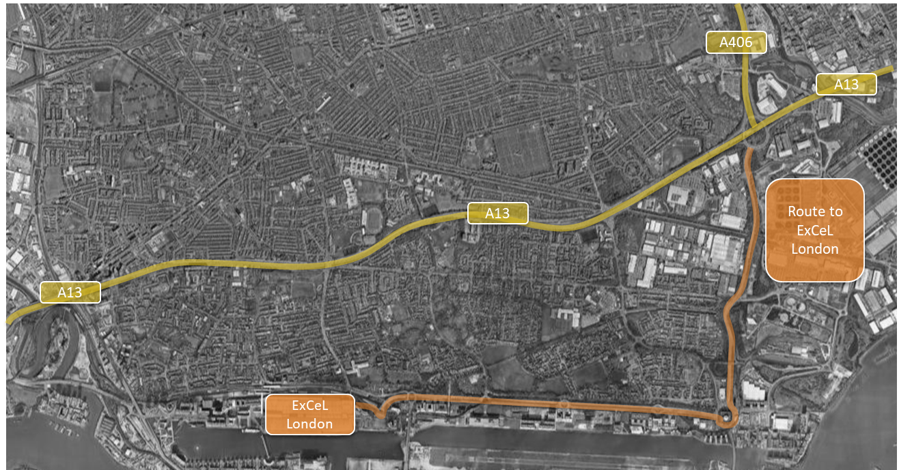  ExCeL London is accessed only via Royal Albert Way. Any vehicles approaching the site from the A13 /A406 Beckton Roundabout, should exit onto the A1020 Royal Docks Road, until Gallions Roundabout. Take the fourth exit onto Royal Albert Way and continue westbound along Royal Albert Way until the ExCeL London Roundabout. Vehicles should then go down Sandstone Lane and into the traffic marshalling area, to await further instructions from the ExCeL traffic team.  There is no access for event vehicles via Seagull Lane. All event traffic should use the route detailed above.
Arriving onsite to access loading bays | Please have either a printed copy or be able to present the vehicle booking electronically on arrival at the Traffic Marshalling area. Drivers can wait in their vehicle, and the ExCeL traffic team will scan the confirmation.  Once granted access to the loading bay, depending on the size of the vehicle, the following time will have been allocated for unloading and leaving the loading bay: small vehicles 30 minutes, transit vans to 12t vehicles 1 hour and 1 hour 30 minutes for 17t, 25t and articulated vehicles.  When the time slot has expired the vehicle will need to be taken off site or parked in the car park.  In the unlikely event of a delay, all drivers must follow the ExCeL traffic team’s instructions. Please ensure the driver and crew respect our on-site team and remember that abuse directed at any member of staff will not be tolerated and may result in access to the venue being denied.
Delivering to your stand | Deliveries will not be accepted outside the tenancy times specified in the show timetable. Couriers should follow the same directions to get to the venue, however they are not required to book a time slot for access. When they arrive, couriers will be instructed to go to a waiting area where a representative from the exhibiting company must meet them to receive the goods.  If no one from the exhibitor team is available, please make arrangements for the official shipping contractor to receive goods on your behalf – details can be found in the contacts section of this manual. Neither ExCeL London nor the organiser will accept goods on your behalf.
Forklifting, Portering & Storage | [XXX] have been appointed as the official contractor for forklifting, lifting, handling and storage at [Event Name].  The official contractor will be onsite during the build up and break down periods of the show and are available to help with any queries. Please note that there is limited storage available for this show.  If you need assistance or further details please contact [XXX] on the details below:  [NAME]  [TELE No.]  [EMAIL]
Parking | Parking is limited on site for vehicles over 1.9m high. Requests are coordinated on a daily basis by the ExCeL London traffic team. Parking for contractor and exhibitor vehicles up to 2.8m is available on a first-come first-served basis at the cost of £30.00 per day per vehicle.  Parking for larger vehicles may not be available on site and any requests should be directed to the ExCeL London traffic team. If you are unable to secure a space on site, there are off site parking locations in the local area, such as Canary Wharf and Stratford.
Contact details | For any queries please contact: ExCeLTraffic@excel.london
Web Information | https://www.excel.london/voyage-control

